|  |  |
| --- | --- |
| ­­ | Report Automation |
|  | New logo |
| 12/22/2011 | Installation and Setup Guide |
|  | Describes the configuration of the Report Automation application developed for Toxikon Corporation. |

**Contents**

1. Installation Process – Server-Side 1

1.1. Active Directory 1

1.2. SharePoint 1

1.3. SQL Server 3

1.4. Data Entry Web Forms 3

1.5. Final Setup Tasks 4

2. Installation Process – Client-Side 6

2.1. Report Automation Microsoft Word Add-in 6

2.2. Updates 7

2.3. Template Tool Microsoft Word Add-in 7

2.4. Report Automation Administrative Utility 8

2.5. Notes 8

This page intentionally left blank.

1. Installation Process – Server-Side
   1. Active Directory
      1. Introduction

Active Directory is used to control access to the application, the SQL Server database and the SharePoint environment. Each Report Automation user has an Active Directory account and is a member of the RAUsers AD group.

When Creating an ID it is important that the email address of that user is entered into the AD Account on the General Tab of the AD User Properties Dialog box.

* 1. SharePoint
     1. Prerequisites
* Properly installed, licensed and configured Microsoft Office SharePoint Server 2010 (MOSS) Standard Edition
* Report Automation users configured in Active Directory
  + 1. Installation and Setup

1. Create the site to host Report Automation.
2. Create Permission “Approve” to be used to set permissions on each library.
   1. Go to Site Actions
   2. Site Permissions
   3. Select Permission Levels
   4. Select Add Permission Level
   5. Setup the Approve Permission as follows: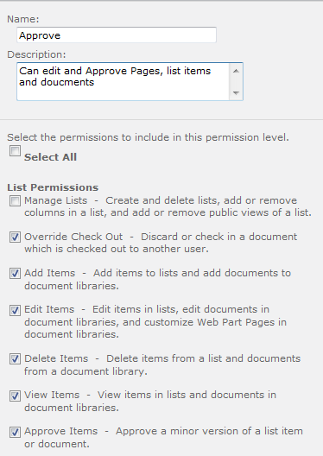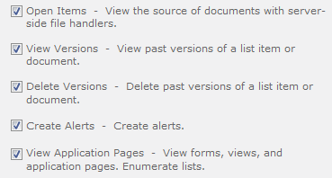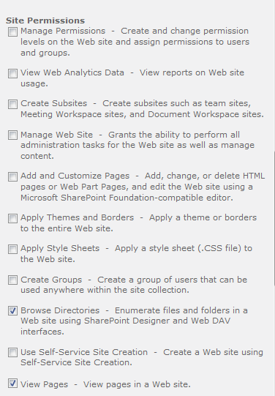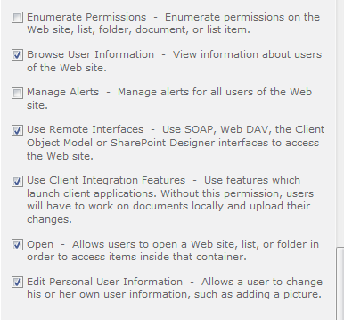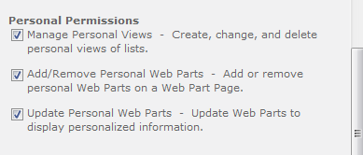
3. Create the SharePoint Groups in the following table (make sure all groups have the “Who can view the membership of the group” setting set to “Everyone"):

|  |  |  |  |  |  |  |
| --- | --- | --- | --- | --- | --- | --- |
| **RA**  **Roles** | **Groups** | **Document Libraries** | | | **Lists** | |
| **SharePoint** | **Studies** | **Report Templates** | **Protocols** | **Tasks** | **Billing**  **Tasks** |
| Study Director | SD | Approve | Approve | Contrib | Contrib | Contrib |
| QA | QA* | Contrib | Approve | Contrib | Contrib | None |
| DPS | DPS* | Contrib | None | None | Contrib | None |
| DC | DC | None | Contrib | Contrib | None | None |
| DE | DE | None | None | None | Contrib | None |
| Billing | Billing | None | None | None | None | Contrib |
| RAAdmin | RA_Admin | Full | Full | Full | Full | Full |

* The group name is a configurable setting in the Report Automation Ribbon application.

1. Creating SharePoint Groups in 2010
2. From Main Page go to Site Actions, Site Permissions
3. Select Create Group
4. Put in Group Name and Fill out form as shown below and click CREATE button at the bottom of the form.

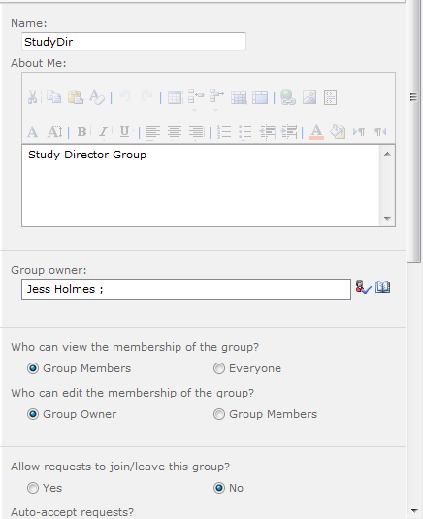

1. Add Active Directory User Accounts to SharePoint Groups
2. From Main Page go to Site Actions, Site Permissions
3. Select a Group Name to go into a specific Group
4. Select New, Add Users:

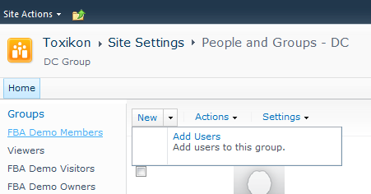

1. Fill in form. Make sure to put the full Domain\username of the Active Directory ID.
2. Create the Studies document library. Navigate to the newly created Library and go to Library Settings > Versioning settings, make sure he below options are used:

* without content approval
* 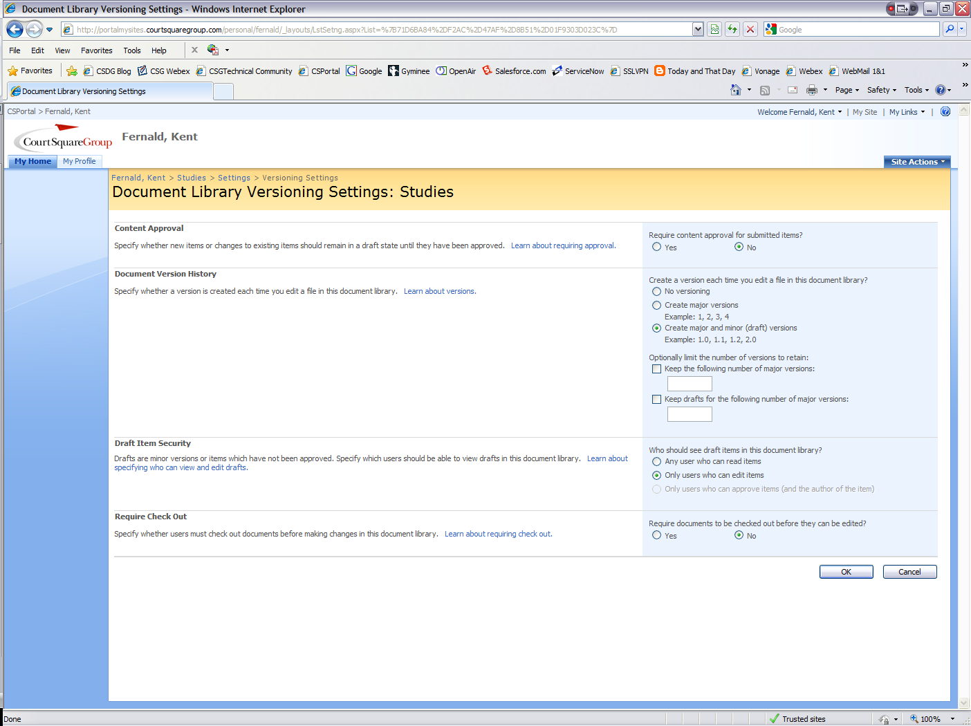with major and minor version
* with only users who can edit items
* without required check out

The name of the Studies folder is a configurable setting within the Report Automation Ribbon application (refer to Installation Process – Client-Side).

1. Create the Protocol document library. Report Automation doesn’t include an approval workflow for Protocols. Navigate to the newly created Library and go to Library Settings > Versioning settings, make sure he below options are used:

* without content approval
* with major and minor versions
* with only users who can edit items
* without required check out

Optionally, an out-of-the-box approval workflow can be setup for Protocols using the Report Template Approval workflow setup instructions as a base (refer to the Report Automation Administrator Reference Guide). The name of the Protocols folder is a configurable setting within the Report Automation Ribbon application (refer to Installation Process – Client-Side).

1. Create the Report Templates document library and configure the out-of-the-box approval workflow according to the setup instructions. The name of the Report Templates folder is a configurable setting within the Report Automation Ribbon application (refer to Installation Process – Client-Side). Navigate to the newly created Library and go to Library Settings > Versioning settings, make sure he below options are used:
   * + - * with content approval
         * with major and minor versions
         * with only users who can edit items
         * without required check out
2. Create the Tasks task list (refer to the Report Automation Administrator Reference Guide).
3. Create the BillingTasks task list (refer to the Report Automation Administrator Reference Guide).
4. Apply permissions from the above table to the respective document libraries and lists.
   * 1. Adding Permissions to Document Libraries
5. Go to Top Level of the site and select the Library name you want to grant permissions to. In this example the Studies Library is used.
6. Once in the Library click the library menu selection

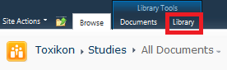

1. Then select Library Permissions from the toolbar (Select “List Permissions” for Lists such as BillingTasks & Tasks)

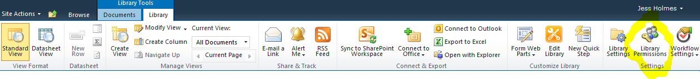

1. Select Grant Permissions
2. Now Add all the groups that have the Contribute Permission per the **chart in section 1.2.2 step 3** See example:

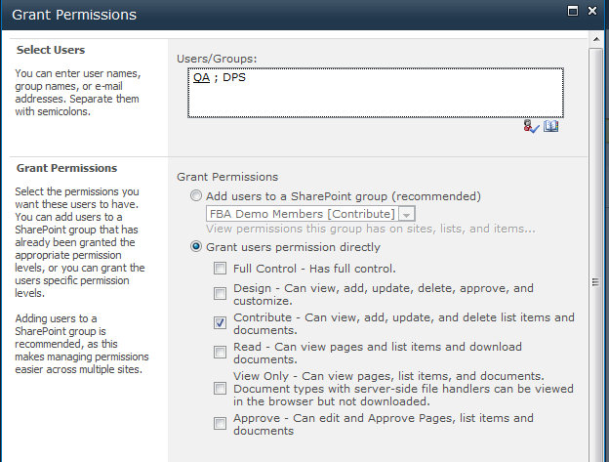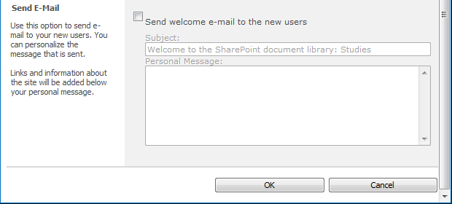

1. Do the Same for all the Groups with Approve Permission
2. Repeat these steps for Each Library. Again all the Libraries are:
   1. Studies
   2. Report Templates
   3. Protocols
3. And Lists are:
   1. Tasks
   2. BillingTasks
   3. Post Setup
4. Upload the four Toxikon-provided protocol documents that correspond to the four study reports. These files are in the Install folder on the Shared 2010 Protocol Templates
5. Upload and start approval workflows (Publish) for the 8 provided report templates (four report templates, four amended report templates). These files are in the Install folder on the Shared 2010 Report Templates
   1. SQL Server
      1. Prerequisites

* Properly installed, licensed and configured Microsoft SQL Server 2005 or 2008
* Report Automation users configured in Active Directory
  + 1. Installation and Setup

1. Using SQL Server Management Studio create the ToxikonRA2010 (in the test environment call it ToxikonRA2010Test) database using the provided scripts.
   * BuildDB.sql
   * FillEmpty.sql
   * FillOrdinal.sql
   * FillProtocols.sql
   * FillUsers.sql
2. Grant the AD RAUsers group appropriate permissions on the database (db_datareader and db_datawriter).
3. The database contains:

* Data for static tables such as tblOrdinal
* Protocol records for the four protocols
* One RAAdmin user with the username Toxikon_RAAdmin

1. (This step is for the test environment only). Run the DB Script FillTestData.sql that will fill tables with test data to be used for verification and testing.
2. Using SQL Server Management Studio change the value of the txtUserName field to match the AD username of a user who will be a member of the RAAdmin role.
   1. Data Entry Web Forms
      1. Initial Install and Setup

On SharePoint server, unzip/unrar the InstallRAForms.rar that is supplied with the software package

1. On the SharePoint server, unzip the InstallRAForms.zip that is supplied with the software package
2. Run the setup.exe as an Administrator, click Next then enter the settings:
   * Site – <Name of the SharePoint site>
   * Virtual Directory – ToxikonDE
   * Application Pool – Same as site app pool
3. Open IIS and drill down to the site where the ToxikonDE was installed. Remove the ToxikonDE application that was created by the installer
4. Expand _layouts, right click on ToxikonDE and Convert to application
5. Open C:\Windows\assembly, confirm RAForms is here (the dll was added correctly)
6. Add the database ConnectString to the web.config file found at C:\Inetpubs\wwwroot\wss\VirtualDirectories\<site>. In the ConnectionStrings section of the file, the setting is:

<add name="ToxikonConnectionString" connectionString="Data Source=<SQL Server Name>;Database=<Database Name>;Integrated Security=SSPI;User ID=<DB User Name>;Password=<DB Password>" providerName="System.Data.SqlClient"/>

1. Add RAForms to the list of safe controls in the web.config file found at C:\Inetpubs\wwwroot\wss\VirtualDirectories\<site>. In the Settings section of the file, the setting is:

<SafeControl Assembly="RAForms,Version=1.0.0.0, Culture=neutral,PublickeyToken=6c87ecf3329e4b47" Namespace="RAForms" TypeName="*" Safe="True" />

1. Add the tag below to the tagMapping section of the web.config file found at

C:\Inetpubs\wwwroot\wss\VirtualDirectories\<site>

<remove tagType="System.Web.UI.WebControls.SqlDataSource, System.Web, Version=2.0.0.0, Culture=neutral, PublicKeyToken=b03f5f7f11d50a3a" />

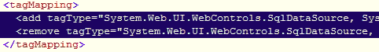

1. Confirm that the new application uses the same application pool as its parent.
2. Restart IIS.
   * 1. Updating Web Forms
3. Copy the new .ASPX, .JPG, .CSS and web.config files to the folder with existing source files.
4. Copy the new .DLL to the BIN folder within said folder.
5. Add the DLL to the GAC by executing AddToGAC.bat (provided with original distribution).
6. Restart IIS.
   1. Final Setup Tasks
      1. Add Users to RAAdmin
7. Connect to the site using the Toxikon username configured for the RAAdmin user (step 3 of SQL Server installation).
8. Open the users form (Site URL + _layouts + <foldername from step 1 of web forms initial install> + /users.aspx).
9. Click the New button and add additional Toxikon users where:

* Username is the user’s AD username
* User Role is the user’s role within Report Automation
* Full Name is the user’s full name (as it will appear on reports)
* Email is the user’s e-mail address
* Phone is the user’s phone number

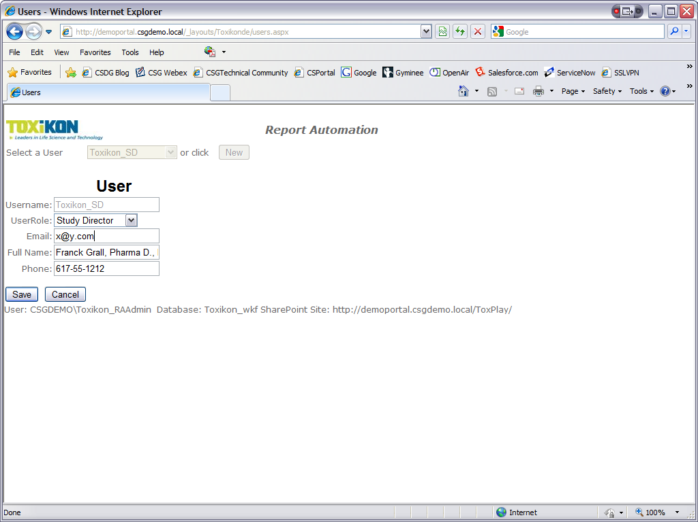

* + 1. Add Study Director and QA Signature Images to Database

Following the instruction in the Report Automation Administrators Guide, use the RAAdmin utility to add signature images for the users with Study Director and QA role.

1. Installation Process – Client-Side
   1. Report Automation Microsoft Word Add-in
      1. Prerequisites

* MS Word 2010
* Microsoft Outlook 2010
* Adobe Reader 8.0 or 9.0
* VSTO Runtime (On Install CD)
* SQL Server client (Ver 10, On Install CD)
  + 1. Setting up the Application Folder Structure
* On the root folder of the Install CD open the folder 02 – RA Ribbon Local Folder
* Create a directory on the C:/ drive called “Toxikon”, inside this directory create a new directory “Temp”, inside of “Temp” create a new directory “Compare”
* Copy the following items from the CD to the C:/Toxikon directory: draft.pdf, pdftk.exe
  + 1. Installing the RA Ribbon Add-on

1. Copy RA Ribbon Installation files to an appropriate file share.
2. On the file share, open the folder Application Files, then open the folder Toxikon Report Automation_n_n_n_n where n.n.n.n is the application version. Find the file, Toxikon Report Automation.dll.config.deploy within that folder.
3. Confirm that the settings in Toxikon Report Automation.dll.config.deploy match the environment:

| **Setting** | **Purpose** | **Typical Value** |
| --- | --- | --- |
| SPSiteURL | SharePoint site URL | https://<SharePoint Site> |
| DBConnectionString | Database connection information | Provider=<valid connection string> (must match SQL client) |
| SPStudiesFolder | Top level folder name for studies | Studies |
| SPProtocolsFolder | Top level folder name for protocols | Protocols |
| SPReportTemplatesFolder | Top level folder name for report template | Report Templates |
| LocalFolder | Folder on local workstation | C:\Toxikon\ (note trailing backslash) |
| LocalTempFolder | Folder on local workstation for temporary files | C:\Toxikon\Temp\ (note trailing backslash) |
| CustomDictionaryPath | Path to custom dictionary | C:\Toxikon\Toxikon.dic |
| ReportPassword | Password used to protect reports |  |
| QAGroupName | SharePoint group name for QA | QA |
| DPSGroupName | SharePoint group name for DPS | DPS |
| SendEmailWhenAssignTask | Whether or not to send email when assigning task | True or False |
| Domain | Domain name | <valid domain> |

* + 1. First Time Installation

1. From the root folder on the Install CD open the folder named: 03 - RA Ribbon Setup Files
2. Execute SETUP.EXE. Click Install to the certificate warning message.
   1. Updates

Execute SETUP.EXE within the file share installation directory. Click Install to the certificate warning message.

* 1. Template Tool Microsoft Word Add-in
     1. Prerequisites
* MS Word 2007
* VSTO Runtime V3 SP2
* SQL Server client
  + 1. Prior to First Installation

1. Copy Template Tools Installation files to an appropriate file share.
2. On the file share, open the folder Application Files, then open the folder TemplateTool_n_n_n_n where n.n.n.n is the application version. Find the file, TemplateTool.dll.config.deploy within that folder.
3. Confirm the settings in TemplateTool.dll.config.deploy match the environment:

| **Setting** | **Purpose** | **Typical Value** |
| --- | --- | --- |
| DBConnectionString | Database connection information | Provider=<valid connection string> (must match SQL client) |
| ReportPassword | Password used to protect reports |  |
| Domain | Domain name | <valid domain> |

* + 1. First Time Installation

Execute SETUP.EXE within the file share installation directory. Click Install to the certificate warning message.

* + 1. Updates

Execute SETUP.EXE within the file share installation directory. Click Install to the certificate warning message.

* 1. Report Automation Administrative Utility
     1. Prerequisites:
* SQL Server client
  + 1. Prior to First Installation:

1. Copy Report Automation Administrative Utility Installation files to an appropriate file share.
2. On the file share, open the folder Application Files, then open the folder RAAdmin_n_n_n_n where n.n.n.n is the application version. Find the file, RAAdmin.exe.config.deploy within that folder.
3. Confirm the settings in RAADmin.exe.config.deploy to match the environment:

|  |  |  |
| --- | --- | --- |
| **Setting** | **Purpose** | **Typical Value** |
| DBConnectionString | Database connection information | Provider=<valid connection string> (must match SQL client) |
| Domain | Domain name | <valid domain> |

* + 1. First Time Installation

1. Execute SETUP.EXE within the file share installation directory.
2. Click Install to the certificate warning message.
   * 1. Updates
3. Execute SETUP.EXE within the file share installation directory.
4. Click Install to the certificate warning message.
   1. Notes
      1. Programmatic Access to Outlook

The Report Automation Ribbon uses Outlook to send task assignment emails. The default Outlook security setting for Programmatic Access is “Warn me about suspicious activity when my antivirus software is inactive or out-of-date (recommended).”

**IF** the warning message is triggered, it may disrupt the application and result in emails not being set or other problems. The recommend solution is the recommended setting along with up-to-date antivirus software. The setting is accessed from the Outlook Tools menu under Trust Center… Select Programmatic Access from the left pane of the Trust Center dialog.

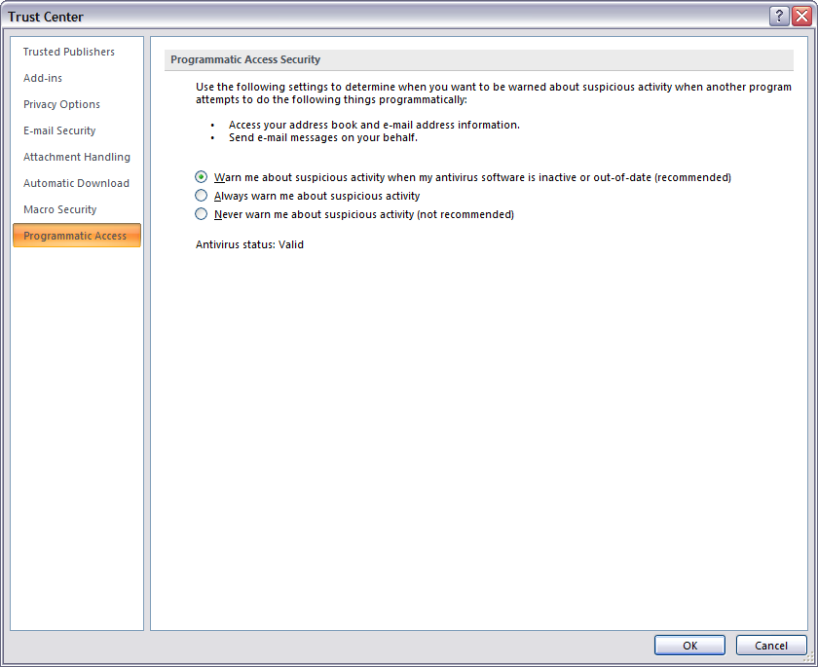

* + 1. Digital Signatures

1. The first time a Report Automation Ribbon user attempts to digitally sign a document, the following dialog box is displayed.

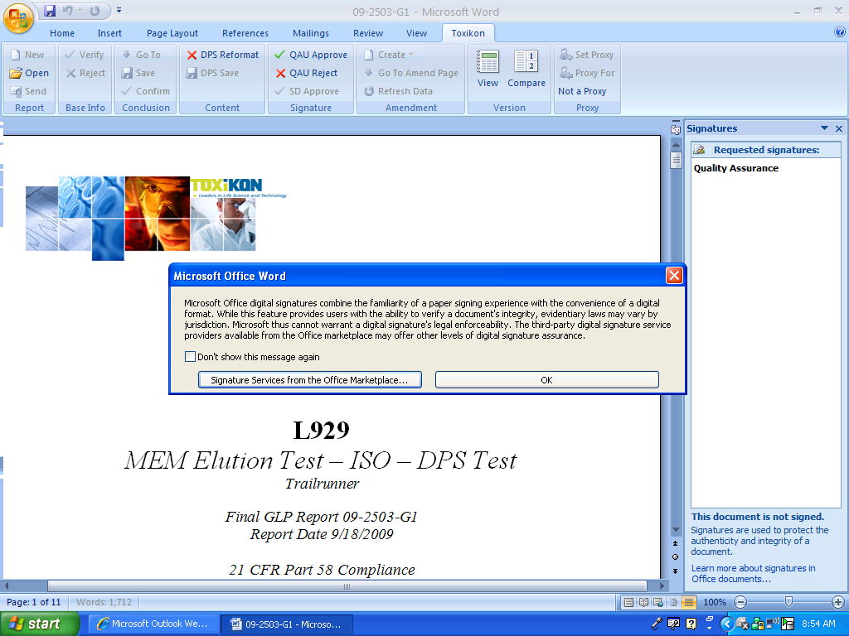

1. Select the “Don’t show this message again” checkbox and then the OK button. The following dialog box is displayed.

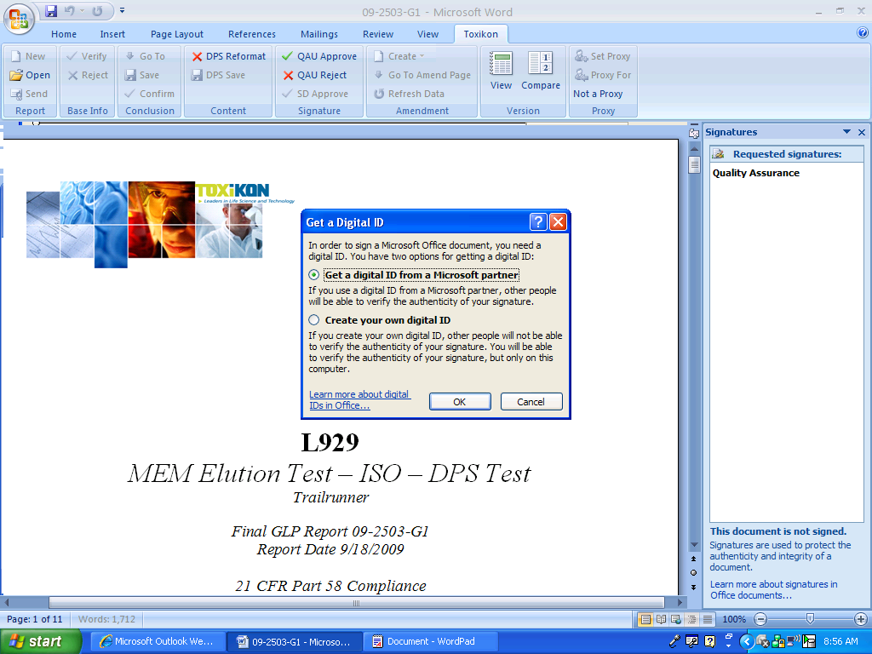

1. If Toxikon does not use a third-party certification authority, the user should select the “Create your own Digital ID” radio button and click OK. The following dialog box is displayed.

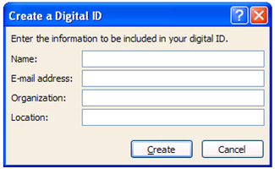

1. The user should enter the applicable information and click Create.
   * 1. Accepting Local Credentials

If Toxikon does not user a third-party certification authority, each signer must be added to the user’s trusted list. Otherwise, the signature is marked as invalid. To add a signer to the trusted list:

1. Open a document signed by the signer.
2. Click Show Signatures button in the message bar.
3. 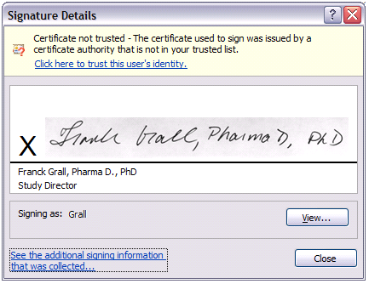In the Signature pane, right-click the invalid signature and select Signature Details.
4. If you trust this user, click the “Click here to trust this user’s identity” link to add the user to your trusted list.
5. 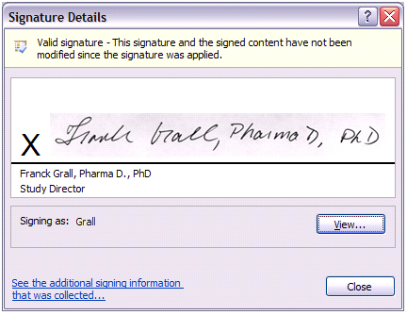Once the signer is in the trusted list confirm that the signature is valid.